Character Maps

Character maps are one of the most powerful features for getting the most out of your time, art and game file space. Character maps are the trick that can allow you to create all the variations of a character vehicle, etc. that can be visually changed by picking up power-ups, new weapons, being effected by magic and so forth.

Character Maps rely entirely on your careful organization of the image folders in your project folder and the images within them. Char Maps are simply a way of telling Spriter (and a game) what to do with images from a specific folder. Here's a simple example:

Let's say the character in your game has a special power where his head becomes invisible. Here's how you'd create a Character Map to handle this visual variation of the character.
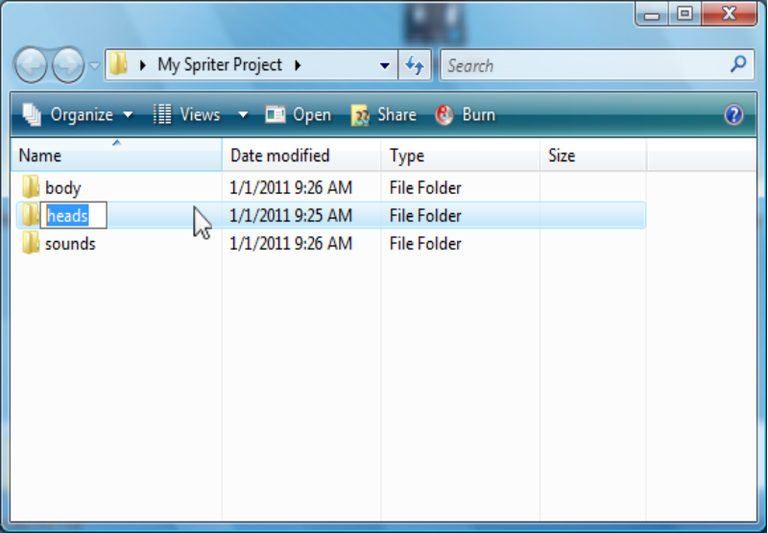
- While creating your project folder you should have created a specific folder for all of the head images that will be used to animate the player character..perhaps called “player heads”

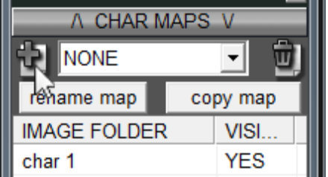
- Click on the “Create Char Map” button just above the “Char Maps” list in the “Image Parts” window and use the dialogue that appears to name the Character Map whatever you'd like. This Char Map will be created and automatically selected.

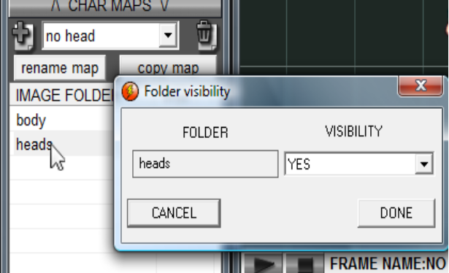
- Double click on the name of the image folder which contains all of the characters head images. This will bring up the “Folder Visibility” dialogue. Use this dialogue to set the visibility of this image folder to “NO”. This tells Spriter that for this version of the character (Char Map), any of the images from this folder (the one wit hall the head images) are not to be drawn at all.

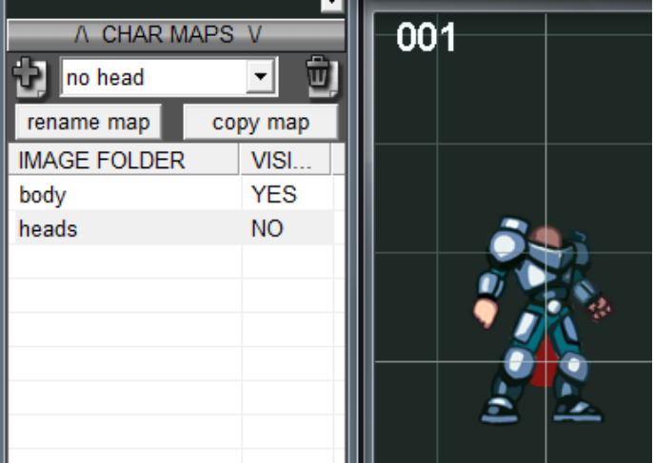
Once you clicked “DONE”, your characters head should have disappeared! To get his head back, simply remove all Char Maps by selecting “NONE” in the “Char Maps” pull down list just above the “IMAGE FOLDER” list in the “Image Parts” window.

Character Maps aren't just great for making parts of your character's anatomy disappear.. Here are some other possibilities to consider:

- Your character starts with no shield but can acquire one. (Animate your character with shield images in a shield folder, then create a “shieldless” Char Map with the shield folder set to “NO”). This would work great for things like capes too.
- Your character can acquire different looking armor or helmets! This is a bit trickier. Instead of setting a folders visibility to “NO” , we would actually set one folder to display images from one of the other folders instead! If you do so, Spriter will look for an image with the same name, but from this new folder and use it instead of the original image from the original folder. So lets say you have the characters original head in a folder called “basic head”, and then you have a set of images in a second folder called “helmet head” which contains clones of the images from the “basic head” folder (same size, same exact file names) EXCEPT that you've gone in and drawn a helmet on these heads. If you create a Char Map that sets the visibility of the “basic head” folder to “helmet head”, then Spriter will swap the basic head with the helmeted head in all of the frames and animations! But only while this Char Map is selected of course... the actual data of your original frames is unchanged.

You can use this trick (no. 2) for things like totally different chest armor, boots, weapons, shields, etc!

